BIA 654 B: Experimental Design II

**Ephraim Schoenbrun**

CWID: 104-20-702

Date of Submission: **April 4, 2017**

Assignment:

**Assignment #7**

# **Ethical Conduct**

|  |
| --- |
| The following statement is printed in the Stevens Graduate Catalog and applies to all students taking Stevens courses, on and off campus.  “Cheating during in-class tests or take-home examinations or homework is, of course, illegal and immoral. A Graduate Academic Evaluation Board exists to investigate academic improprieties, conduct hearings, and determine any necessary actions. The term ‘academic impropriety’ is meant to include, but is not limited to, cheating on homework, during in-class or take home examinations and plagiarism.”  Consequences of academic impropriety are severe, ranging from receiving an “F” in a course, to a warning from the Dean of the Graduate School, which becomes a part of the permanent student record, to expulsion.  *Reference: The Graduate Student Handbook, Academic Year 2003-2004 Stevens*  *Institute of Technology, page 10.*  Consistent with the above statements, all homework exercises, tests and exams that are designated as individual assignments MUST contain the following signed statement before they can be accepted for grading. ____________________________________________________________________  I pledge on my honor that I have not given or received any unauthorized assistance on this assignment/examination. I further pledge that I have not copied any material from a book, article, the Internet or any other source except where I have expressly cited the source.  Signature: Date: April 4, 2017  Please note that assignments in this class may be submitted to [www.turnitin.com](http://www.turnitin.com/), a web-based anti-plagiarism system, for an evaluation of their originality. |

1. The makers of “Cats Love It” cat litter are facing a serious problem. Retail customers are reporting that cartons of the firm’s premium brand cat litter are leaking the product onto store shelves. The company realizes that while cat lovers are used to cleaning stray sprays of litter tracked through the house, they are not willing to put up with cartons that leak on the way home. Management has determined that the problem is with the carton-sealing process. Cartons are filled and sealed on a production line run by 20 workers. The company decides to perform 3-factor factorial experiment. A run consists of filling and sealing 200 cartons. The factors to be tested and levels of each are shown below.

* **Factor A** is line speed with the minus level at 22 cartons per minute and the plus level at 30 cartons per minute.
* **Factor B** is the pressure applied by the gluing machine, with the minus level being lower pressure and the plus level being higher pressure.
* **Factor C** is the amount of glue used, with the plus level being the current amount and the minus level being 40% less glue.
* The response is the proportion (%) of cartons that leak, whose values are observed as 8, 45, 47, 10, 8, 40, 41, 8, listed in the standard order.
* Estimation results (You computed these for A, B, and AC in your previous Homework problem) are given as:

|  |  |  |  |  |
| --- | --- | --- | --- | --- |
| Average | 25.875 |  | AB | −34.75 |
| A | −0.25 |  | AC | −0.25 |
| B | 1.25 |  | BC | −0.75 |
| C | −3.25 |  | ABC | 2.25 |

1. Suppose each response is the average of two replicated runs (note the numbers have been rounded). Suppose the pooled estimate of the variance of the response of an individual run is equal to 16. Based on 95% confidence intervals for an effect, which effects are significant? (Note: If a 95% confidence interval does not contain 0, then you can reject H0 with α = 0.05 when your H1 is two-sided.)

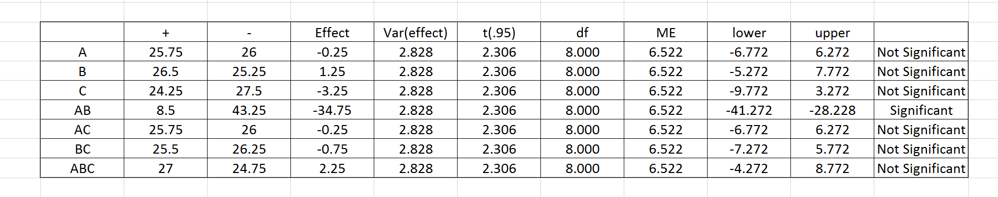

**None of the main effects are significant. The only effect that is significant is the AB interaction effect.**

1. What is the regression prediction equation? (Note: In the regression prediction equation, only significant effects are included. The intercept term in that equation is the mean response (i.e., the average of responses).)

**Because the only effect that is significant is the AB interaction effect, the regression prediction equation is as follows:**

$$Y=Intercept+β(\frac{AB Effect}{2})*AB$$

$Intercept=\frac{\sum{\left(X_{i}-\overline{X}\right)}}{n}$**= 25.875;**

$$Y=25.875-17.375*AB$$

1. What levels would you recommend for each factor? What is the predicted response (proportion of leaking cartons) if your recommended settings are used?

**Given that AB is the only factor that displays a significant factor in the leakage of the cartons, we observe that the percentage of faulty cartons is minimized when AB is positive, resulting in an 8.5% anticipated leakage probability. We can conclude, then, that the optimal settings for the company is when A and B are either both negative or positive. When looking at the responses of these two options, we find that setting both on a lower setting improves the quality of the cartons overall, although setting all three factors to positive would gain the same result. Under these conditions, the predicted response would be 8%.**